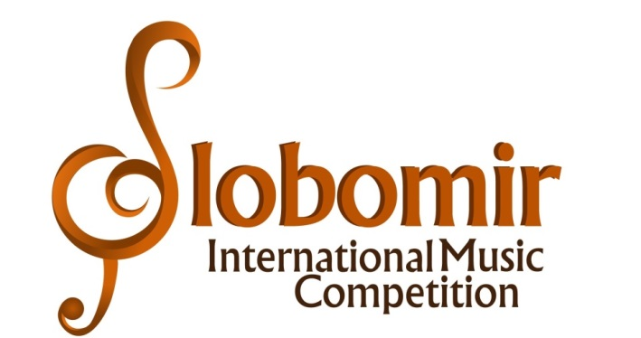
VII SLOBOMIR INTERNATIONAL MUSIC COMPETITION 2021

REPERTORY RULES AND CATEGORIES
The appropriate category must be selected according to age at the time of the application deadline, April 25, 2021. One participant can participate in several different categories. Participants may compete in the older age group but may not compete in the younger age group.

- PIANO SOLO
JUNIOR : 30 EUR
Baby category, 2014 and younger - 3 min; free program
Pre-category, 2012 and younger - 6 min; free program
I category, 2010 and younger - 9 min; free program
II category, 2008 and younger - 12 min; obligatory program: sonata or sonatina (I movement or II and III movement); or variations; or rondo.
Category III, 2006 and younger - 15 min; obligatory program: sonata or sonatina (I movement or II and III movement); or variations; or rondo.
JUNIOR ARTIST: 35 EUR
IV category, 2004 and younger - 18 min; obligatory program: sonata (I movement or II and III movement); or variations; or rondo.
V category, 2002. and younger - 21 min; obligatory program: sonata (I movement or II and III movement); or variations; or rondo.

SENIOR: 40 EUR
VI category (students of I or II year of study) - 30 min; one virtuoso etude required
VII category (students III, IV and V years of study) - 40 min; one virtuoso etude required
VIII category (free category up to 35 years of age) - 50 min; one virtuoso etude required

- PIANO DUA (piano in four hands, for two pianos or combined)

JUNIOR: 40 EUR
Baby category, 2014 and younger - 3 min; free program
Pre-category, 2012 and younger - 5 min; free program
A category, 2010 and younger - 7 min; free program
B category, 2008 and younger - 10 min; free program
C categories, 2006 and younger - 12 min; free program

JUNIOR ARTIST: 45 EUR
D category, 2004 and younger - 15 min; free choice program (of which at least one composition must be originally written for piano)
E category, 2002 and younger - 17 min; free choice program (of which at least one composition must be originally written for piano)
SENIOR: 50 EUR
F category (students of I and II years) - 25 min; free choice program (of which at least one composition must be originally written for piano)
G category (students III, IV and V years) - 30 min; free choice program (of which at least one composition must be originally written for piano)
H category (free category up to 35 years) - 40 min; free choice program (of which at least one composition must be originally written for piano)
- COMPARATIVE PIANO (participants who are in the theoretical department, musicology, ethnomusicology, composition, conducting, solo singing or learn some other instrument in high school / academy)

JUNIOR ARTIST: 30 EUR
I category (1st and 2nd grade of high school) - 10 min; obligatory program: sonata or sonatina (I movement or II and III movement); or variations; or rondo.
II category (3rd and 4th grade of high school) - 13 min; obligatory program: sonata or sonatina (I movement or II and III movement); or variations; or rondo.
SENIOR: 35 EUR
III category (I and II year of study) - 15 min; obligatory program: sonata or sonatina (I movement or II and III movement); or variations; or rondo.
IV category (III, IV and V year of study) - 18 min. obligatory program: sonata or sonatina (I movement or II and III movement); or variations; or rondo.

The repertoaire in the disciplines Piano Solo and Comparative Piano must be performed by memory. In the Piano Duo discipline, it is not necessary to perform the program by memory. If a certain work is performed for the first time, at the request of the jury, it is necessary to send the musical material (musical score ) of the given work in electronic form.

