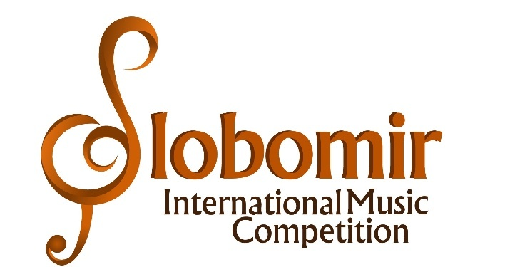

VII SLOBOMIR INTERNATIONAL MUSIC COMPETITION 2021

PIANO SOLO –baby category, precategory, I, II i III category
Olga Borzenko, Serbia
Aida Gavrilova, Spain
Marija Maksimova, Macedonia
Amsal Ganović, Bosnia and Hercegovina
Dario Zombra, Bosnia and Hercegovina

PIANO SOLO – IV, V, VI, VII i VIII category
Jokuthon Mihailović, Serbia
Dubravka Jovičić, Serbia
Aleksandra Radosavljević, Bosnia and Hercegovina
Arsen Čarkić, Bosnia and Hercegovina
Neven Šobajić, Serbia

PIANO DUO AND COMPARATIVE PIANO
Tea Dimitrijević, Serbia
Aleksandra Radosavljević, Bosnia and Hercegovina
Arsen Čarkić, Bosnia and Hercegovina
Neven Šobajić, Serbia
Dario Zombra, Bosnia and Hercegovina

