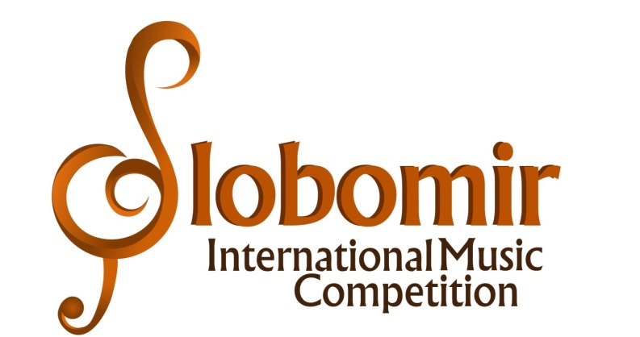
VIISLOBOMIR INTERNATIONAL MUSIC COMPETITION 2021

GENERAL RULES OF THE COMPETITION
The organizer of the VII International Piano Competition SIMC 2021 is Slobomir P University.
All information about the competition can be found on the website: www.au.spu.ba.
The SIMC VII competition will be organized online for the first time from 7-10. May 2021 in the disciplines Piano Solo, Piano Duo and Comparative Piano.
1) The application period is from January 25, 2021. to 25.04.2021.
2) Videos of the contestants will be published on the YouTube channel 07.05. - 10.05.
3) The results of the competition will be published on 15.05.2021 on the competition website. After the results of the competition, only the videos of the winners will remain visible on the home page of the competition, as well as on the Facebook page.
4) Diplomas and feedback will be sent on 25.05. 2021
- PARTICIPANTS
The SIMC International Piano Competition is open to competitors of all nationalities from all over the world and will be held between May 7 and 10, 2021. The competition will take place in one phase and is held entirely online. Participants will compete in different categories, depending on their age. All videos of the participants will be published from May 7 to 10 on the YouTube and Facebook channels Slobomir Simc.

- VIDEO COMPETITION RULES
Videos posted on the Slobomir Simc YouTube channel link must be recorded no later than twelve (12) months before the candidate's registration date. Only unedited recordings will be accepted. The video must always clearly show the performer's face and hands and must be recorded in its entirety (in one continuous frame). Video length should not exceed the time limit specified in the category requirements. By participating in the contest, contestants automatically waive their right to any material (financial) compensation in connection with the eventual publication and distribution of submitted music videos, as well as other materials received by the contest.
Uploading to YouTube can be done using the video's "public" setting (open to all) or the "unlisted" setting (visible to anyone with a link). It takes special care that your recording is not set to the "private" option in order to be accessed.
Please follow the instructions and title your video as follows: Last name and first name (country); In the "Description" field, indicate the name of the competition (VII International Piano Competition SIMC 2021), the age category, as well as the authors and full names of the performed compositions, in that order.

- APPLICATION DETAILS
The participant is obliged to send the following documents:
a) Completed online application form (application form);
b) YouTube link with video recording;
c) Scanned document on paid registration fee;
d) A copy of the document confirming the year of birth;
e) Photograph
Please send all documents in one letter by 25.04.2020 to simcslobomir@gmail.com
The application form can be found on the website of the Competition:www.au.spu.ba

- INTERNATIONAL JURY
The work of the jury is regulated by special rules. Jury members are selected from a group of renowned artists and educators. All decisions of the jury are final. Candidates are required to state the name of the professor in the application. In the event that a member of the jury was, or is a professor of the candidate during the competition, or is related to him, he is exempted from the evaluation of that candidate.
- PRICES
The prizes at the Competition are:
And the prize - from 90 to 100 points;
II prize - from 80 to 89.99 points;
III prize - from 70 to 79.99 points;
PRAISE - from 60 to 69.99 points;
DIPLOMA for participation - for less than 60 points.
The number of prizes is not limited.
Educators whose students win the first prize, the organizer awards honorary diplomas.
The title of Laureate of the "Slobomir International Music Competition" can be awarded to one competitor from I, II and III categories (Primary School) and one competitor from IV, V, VI, VII and VIII categories (secondary school and music academies). The winners of the best prizes will be presented on the competition website, with a portrait of the concert, a biography and their awarded video. The winners of the competition will be awarded a cash prize of 100 EUR.
The honorary diploma with the title "Professor of the competition" will be awarded to the teachers with the highest results (at least two or more first prizes, or one big prize).
In the event of any dispute regarding the interpretation of any part of the rules and regulations of the International Piano Competition SIMC 2021, the decision of the management and the jury of the competition will be final and cannot be appealed. The Competition Authority reserves the right to amend any rules or regulations contained herein if deemed necessary for the conduct of the competition. Competition SIMC 2021 reserves the right to cancel or change the course of the competition in case of unforeseen circumstances. Only in that case, the registration fee will be returned to the participants.
- INSTRUCTIONS FOR PAYMENT OF REGISTRATION FEES
Participants from Bosnia and Herzegovina pay the amount to the account marked - Registration fee for SIMC 2021:
NAŠA BANKA 554-001-00002647-94 with the indication Registration fee for SIMC 2021

Participants from abroad pay the amount to the account USD / EUR with the indication - Registration fee for SIMC 2021:

NASA BANKA AD
BIJELJINA, BIH
SWIFT: PAVLBA22
Beneficiary: SLOBOMIR P UNIVERZITET
PAVLOVICA PUT BB
BA-76300 BIJELJINA
IBAN CODE: BA395547800004590168
Correspondent Bank of NASA BANKA AD:
SBERBANK MOSCOW
MOSCOW
SWIFT: SABRRUMM

The participation fee cannot be refunded.
IMPORTANT NOTE: Do not forget to state the name of the candidate when paying !!!

