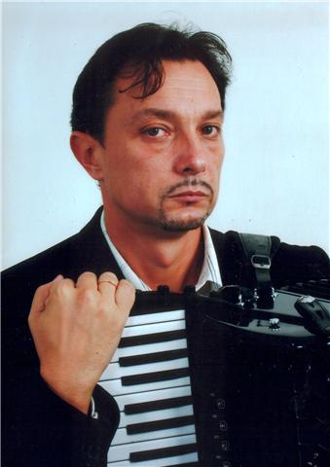**dr Vojin Vasović**

PROFESOR

|  |  |  |
| --- | --- | --- |
|  |  | |
| **Email adresa:** | |  | |

**Bibliografija**